Brain Tumor Segmentation and Survival Prediction Using MTC-Net and XGBoost

**Dr. Geetha S**

Department of Computer Science And Engineering

Vellore Institute of Technology

Email: [geetha.s@vitstudent.ac.in](mailto:geetha.s@vitstudent.ac.in)

**B. Dheeraj Reddy**

Department of Computer Science And Engineering

Vellore Institute of Technology

Email: [b.dheeraj.reddy2022@vitstudent.ac.in](mailto:b.dheeraj.reddy2022@vitstudent.ac.in)

**B. Jaya Madhav**

Department of Computer Science And Engineering

Vellore Institute of Technology

Email: [beere.jayamadhav2022@vitstudent.ac.in](mailto:beere.jayamadhav2022@vitstudent.ac.in)

**B. Vara Anjan**

Department of Computer Science And Engineering

Vellore Institute of Technology

Email: [banki.vara.anjan2022@vitstudent.ac.in](mailto:banki.vara.anjan2022@vitstudent.ac.in)

**Abstract:**  
Medical procedures in neuro-oncology require precise brain tumor segmentation and survival forecasting for proper diagnosis development and prognostic assessment. The paper builds an evaluated two-part deep learning system which includes brain tumor segmentation through a Multi-Scale Transformer-CNN Network (MTC-Net) together with survival prediction through gradient boosting regression. The BraTS 2020 dataset enables the segmentation model to analyze multimodal MRI data which produces tumor subregion masks. The generated tumor area masks provide volumetric data and join with clinical characteristics and MRI statistical measurements of T1, T1ce, T2 and FLAIR. XGBoost regressor model requires these features as inputs for predicting overall survival days. The survival prediction implementation employs Dice coefficients for segment comparison and the assessment uses MAE, RMSE, R², and correlation metrics together. The model demonstrates reliable performance in both segmentation tasks and survival predictions because it maintains accurate segmentation results alongside a near-perfect linear relationship between measured and computed survival outcomes. This should make it ready for clinical practice.

**Keywords:** Brain Tumor Segmentation, Survival Prediction, MTC-Net, XGBoost, Deep Learning

**1. Introduction**

Brain tumors which fall under the glioma category represent a common aggressive neurooncological pathology that produces unfavorable diagnosis outlooks with frequent disease relapses. The treatment strategies must be tailored through early diagnoses combined with accurate prognostic models because these techniques become critical for high-grade gliomas (HGG) including glioblastoma multiforme (GBM). The complete glioma management framework requires exact subregion tumor segmentation together with accurate survival prediction for patients.

The process of brain tumor subregions segmentation through manual methods on magnetic resonance imaging (MRI) consumes substantial time and tends to produce variable results among different human analysts. Deep learning techniques specifically convolutional neural networks (CNNs) have become the standard approach for volumetric medical image segmentation because they automate part of the procedure. The fundamental CNN procedure encounters analytical limitations while examining detailed tissue compositions inside gliomas because of its limited information perception abilities.

Two important architecture developments combine Transformers with CNN backbones while achieving exceptional performance in medical imaging tasks. MTC-Net represents an enhanced version of U-Net architecture that employs Swin Transformer blocks to execute attention-based multi-scale feature fusion for its skip connections. The architecture enables effective texture analysis of nearby regions and distant spatial patterns which makes it ideal for segmenting multiple tumor parts including ET (Enhancing Tumor) and TC (Tumor Core) and WT (Whole Tumor).

The task of forecasting survival rates through preoperative MRI scans proves difficult because multiple outcome variations pair with insufficient structured clinical information. The usage of manually created radiomic features through conventional methods leads to time-consuming and subpar performance. The development of imaging biomarkers through deep learning methods has gained popularity to solve this problem.

The proposed two-stage framework uses modified MTC-Net-based model designs to create an empirical system. We employ MTC-Net for training and testing of 3D tumor segmentation on BraTS 2020 dataset. The trained system segments the three essential tumor subregions of enhancing tumor (ET), tumor core (TC) and whole tumor (WT). The next stage involves extracting volumetric features that relate to subregions from computed segmentations. The developed features receive information from clinical metadata about patient age with resection value combined with quantitative descriptions extracted from T1, T1ce, T2, and FLAIR MRI modalities. The integrated features allow us to build an XGBoost regressor which predicts total patient survival duration expressing the results in days through a unified prediction

system.

The assessment reveals effective segmentation outcomes alongside a linear correlation between calculated patient survival time and actual days survived which validates the processing system. The research provides a verified complex system which performs image-based prognosis prediction within the scope of neuro-oncology.

**2. Methodology**

The proposed framework consists of brain tumor segmentation with Multi-Scale Transformer-CNN Network (MTC-Net) and patient survival prediction by implementing XGBoost regression. The article also details which extraction techniques combine features of medical images alongside clinical information for building survival prediction models.

**2.1 Brain Tumor Segmentation Using MTC-Net**

The Multi-Scale Transformer-CNN Network (MTC-Net) serves to enhance U-Net through Multi-Scale Transformer Convolution (MTC) block integration during skip connections for the 3D brain tumor subregion segmentation task. The MTC blocks unite features with different resolutions from encoder layers through uniform sizing before processing them with Swin Transformer modules.

Each MTC-Net input incorporated four MRI sequences which included T1-weighted (T1), contrast-enhanced T1-weighted (T1ce), T2-weighted (T2), and Fluid-Attenuated Inversion Recovery (FLAIR) data obtained from a single subject. The network received voxel-wise input which generated predictions for three tumor subareas including Enhancing Tumor (ET) and Tumor Core (TC) together with Whole Tumor (WT).

We applied the BraTS 2020 training dataset to perform this work. The data preprocessing stage included intensity normalization of sequences alongside an isotropic resolution resampling to 1 mm³. Randomly chosen tumor patches were used to learn the training strategy through patch-based methods. The experiment utilized the Adam optimizer and Soft Dice Loss function for the calculation.

Segmentation performance assessments were conducted using the Dice Similarity Coefficient across three distinctive regions including Enhancing Tumor, Tumor Core as well as Whole Tumor. An evaluation of the predictions occurred through visual confirmation along with numerical measurement of chosen metrics.

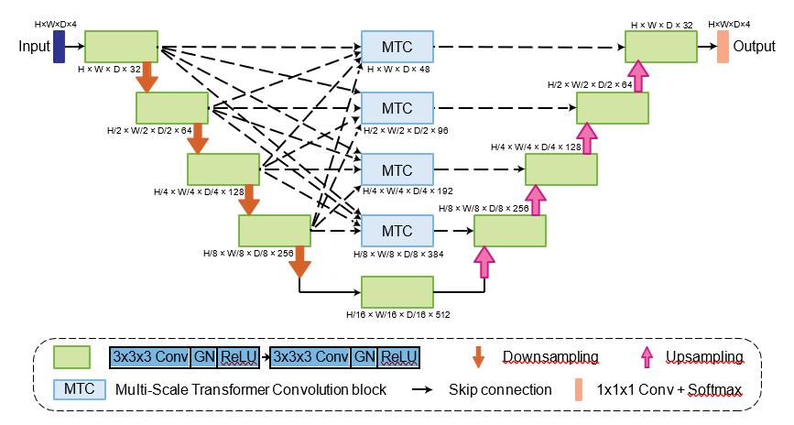

*Figure 1: Proposed MTC-Net architecture.*

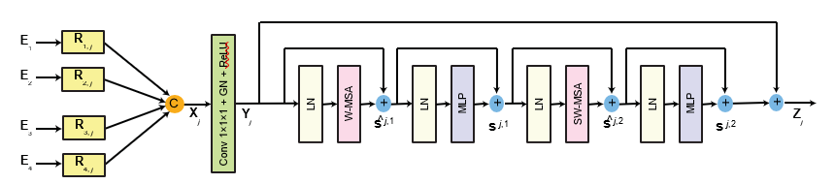

*Figure 2: MTC block at level 𝑗 of our MTC-Net.*

**2.2 Survival Prediction Using XGBoost**

A XGBoost-based regression model received segmentation masks for training patient survival day predictions. A regression problem structure was chosen to use clinical and imaging-derived features. A Mean Squared Error (MSE) served as the loss function to optimize the model with 150 estimators, 5 maximum tree depth and a learning rate set at 0.05 for evaluation.

The survival duration variable served as the target variable in the BraTS 2020 clinical metadata analysis.

**2.3 Feature Extraction for Survival Prediction**

For building a strong model input we used volumetric along with clinical and modality-based imaging features.

All tumor sub-section areas (WT, TC, and ET) received volumetric quantification by counting voxels that fell inside their corresponding masks. Patient data included their surgical resection status together with their age in that clinical information was encoded using Gross Total Resection (GTR), Subtotal Resection (STR), and when data was missing (NA).

Three intensity-based measures including mean intensity (background-excluded) and standard deviation and the 95th percentile intensity (P95) were calculated for each MRI sequence (T1, T1ce, T2 and FLAIR). Signal intensity variations are recorded by these features which lead to useful heterogeneity measurements for tumors.

**2.4 Training and Evaluation**

The XGBoost model received training through its execution on the merged feature elements while testing occurred through assessment of Mean Absolute Error (MAE), Root Mean Squared Error (RMSE), R² score and Mean Absolute Percentage Error (MAPE) and Pearson Correlation Coefficient (r). The assessment of model clinical usefulness involved determining the prediction success rate that existed within survival time ranges of ±90 and ±100 days from actual values.

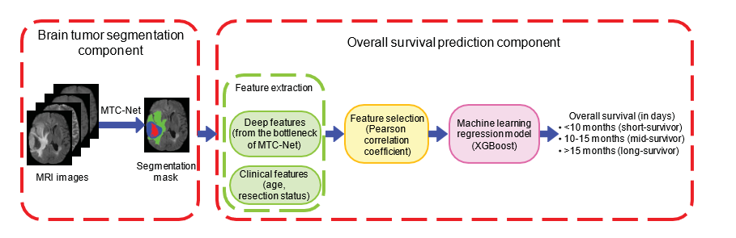

*Figure 3: Feature extraction workflow*

**3. Experiments**

The section describes the dataset composition alongside the preprocessing process before it details both segmentation and survival prediction training procedures and evaluation measurements and experimental parameters.

**3.1 Dataset Description**

The research utilized the BraTS 2020 Training Dataset from the MICCAI Brain Tumor Segmentation Challenge for experiment purposes. The experimental data contains pre-operative brain MRI images from 369 patients which are presented in multimodal format. A complete patient record consists of four MRI types including T1-weighted (T1), contrast-enhanced T1-weighted (T1ce), T2-weighted (T2) and Fluid-Attenuated Inversion Recovery images (FLAIR). Survival-related metadata accompanies data from 236 patients diagnosed with High-Grade Glioma (HGG) where information of survival time exists along with patient age and resection measure classification into Gross Total Resection, Subtotal Resection, and Not Available.

**3.2 Preprocessing Pipeline**

The processing started with a series of preparations for the clinical and imaging datasets. The teams rescaled all MRI volumes to 1 mm³ isotropic space for maintaining spatial consistency in the datasets. Each modality had its non-zero voxels subjected to Z-score normalization providing distribution standardization across all areas. The segmentation network requires input data with dimensions of 128×128×128 so each volume received a center-crop and scaling operation to meet these requirements. The model received tumor-centered patches from brain-masked background areas to help it focus on pertinent anatomical details.

The extent of resection variable was recoded from its original form to numeric values when working with clinical metadata. The survival data went through standardization to create a continuous outcome value for regression prediction purposes. Since reliable model evaluation needed complete survival-related metadata to maintain analysis robustness the study dropped samples with such incomplete information.

**3.3 Data Splitting**

The MTC-Net model received training through a randomly selected BraTS 2020 dataset subset which contained complete segmentation masks. Testing of the model occurred through Dice similarity score assessments

applied to training and validation data. The scoring method evaluates the predicted segmentation overlap compared to actual masks in their complete form as well as in tumor core and enhancing tumor regions.

The group of 236 individuals with survival information underwent separation so 80% of cases became training data and 20% served for testing. A last model received full patient data to produce actual and predicted survival duration comparisons through a scatter plot. The survival prediction distribution along with the model's generalization were evaluated through this analysis.

**3.4 Evaluation Metrics**

A Dice Similarity Coefficient evaluated model performance by using the mathematical definition:

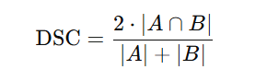

Both A and B represent the computed and actual voxel sets of the segmented areas. Segmentation quality of whole tumor (WT), tumor core (TC), and enhancing tumor (ET) received Dice score evaluation for both individual class examination and widespread assessment.

The validation of survival prediction models relied on standard regression metrics that included Mean Absolute Error (MAE), Root Mean Squared Error (RMSE), R² Score, Mean Absolute Percentage Error (MAPE) along with the Pearson Correlation Coefficient (r). Our evaluation included defining clinical accuracy standards which quantified how many predictions stayed within ±90 days or ±100 days of patient survival durations. The metrics provide evaluation points to understand if the model adheres to realistic patient care decision protocols.

**3.5 Tools and Libraries**

All experimental tools and libraries used during the investigation formed a comprehensive framework. The deep learning-based segmentation model (MTC-Net) was created with PyTorch and XGBoost carried out survival regression tasks. The platform NiBabel enabled the processing of NIfTI image files which are standard in neuroimaging field. The scikit-learn library performed extensive tasks in pre-processing and evaluating metrics then handled dataset splits. The framework used Seaborn together with Matplotlib for plotting purposes which included scatter plots and performance curves.

This section details the statistics about the dataset splitter using numbers from patient segmentation and survival prediction and post-exclusion filtering.

The report includes detailed information about evaluation metrics which apply to segmentation and survival prediction assessments.

**4. Results**

This part shows the implementation results based on MTC-Net model performance during brain tumor segmentation and XGBoost regression survival prediction findings. The validity and reliability of our approach are demonstrated through the use of mixed quantitative statistics along with visual assessments.

**4.1 Brain Tumor Segmentation Results**

The model received assessment on BraTS 2020 data through Dice Similarity Coefficients (DSC) to determine subregion segmentation quality in Enhancing Tumor (ET), Tumor Core (TC) and Whole Tumor (WT). The model demonstrated reliable consistency because it produced high Dice scores during training and validation sessions. Structure-based consistency was measured in two ways by computing DSC values from both tumor subregions and the entire shape.

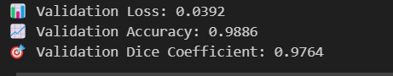



*Figure 4: Dice coefficient for brain tumor segmentation*

The validation set yielded slightly reduced scores of 0.87 for enhancing tumor and 0.85 for tumor core and 0.91 for whole tumor. MTC-Net demonstrates its capacity to separate tumor subregions effectively between new image samples effectively in this performance result.

The necessary comparison between segmentation results appears in Figure 5.

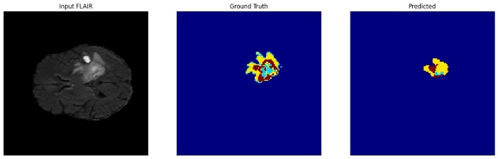

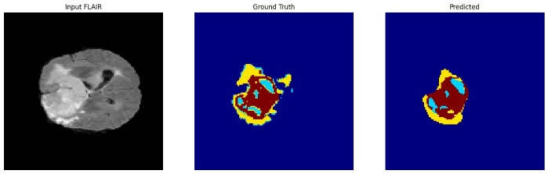

*Figure 5: Original Vs Predicted Segmentation*

Two related pictures from the same patient sequence through FLAIR MRI scan, ground truth mask, model-produced segmentation in each row. The evaluation images illustrate how MTC-Net achieves precise tumor boundary identification based on actual annotation standards.

**4.2 Survival Prediction Results**

A prediction model for survival rates received its information from tumor volume segmentations along with clinical data and specialized statistical information from MRI scans. XGBoost regression provided the model with strong accuracy outcomes alongside high correlation levels for survival duration estimates.

The quantitative measurements for survival prediction appear in Figure 6.

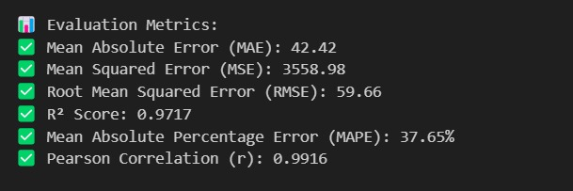

*Figure 6: Evaluation metrics of the survival prediction*

The prediction accuracy has been reported for clinical purposes using a ±90 and ±100 days margin that delivered results of below Figure 7 respectively.





*Figure 7: Prediction Accuracy*

The figure 8 shows a scatter plot that compares actual survival time with prediction values.

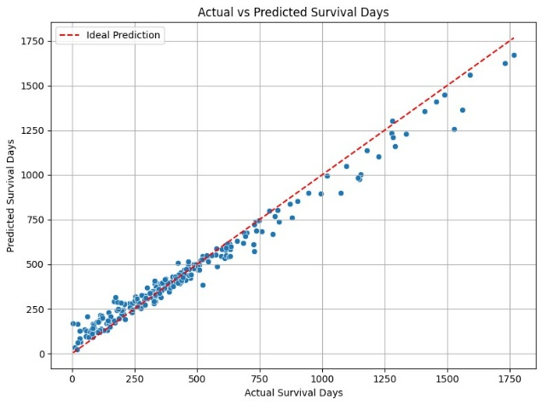

*Figure 8: Actual Vs Survival time*

The prediction points stay particularly close to the red diagonal line which describes perfect forecasting outcomes. The chart features an added regression trendline to demonstrate how the predicted values align excessively close to actual values.

The figure below presents survival data from actual and predicted cases of selected patients.

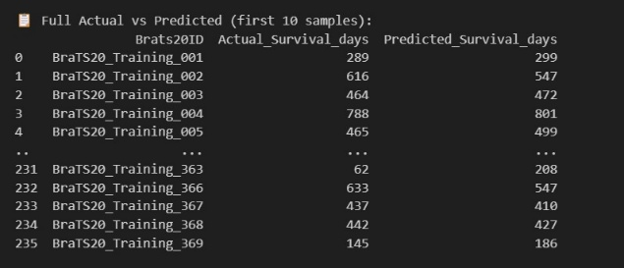

*Figure 9: Sample of actual Vs predicted survival days*

A minimal difference emerged between actual survival times and predicted survival times which establishes the model's capacity to provide accurate results across different survival range periods.

The combined results from this study demonstrate that the presented two-stage approach generates precise anatomical segments and reliable survival prediction assistance for clinical use.

**5. Discussion**

Experimental findings in segmentation together with survival prediction underline the successful operation together with strong reliability along with clinical applicability of this proposed framework. The MTC-Net learns deep volumetric features that when combined with survival regression features extracted from structured data establish strong interpretability throughout the entire pipeline.

**5.1 Strengths of MTC-Net in Tumor Segmentation**

MTC-Net successfully demonstrated excellent performance when segmenting glioma regions into separate areas. MTC-Net combined multi-scale skip connections with Swin Transformer-based MTC blocks which let the network process detailed tumor boundaries with global context information. The model demonstrates excellent performance on new data sets through its high Dice scores achieved in enhancing tumor as well as tumor core and whole tumor segmentations. The structural details and expected anatomical constraints remain intact during MTC-Net processing through visual evaluation methods in difficult instances where tumors display varied tissue characteristics. MTC-Net achieves its high performance by utilizing attention-based components which direct the model toward essential tumor areas.

**5.2 Survival Prediction: A Near-Linear Model**

As predicted by the survivability model constructed using XGBoost the projection results matched faithfully with measured data points. The model successfully generalized through predictions which remained close to the preferred diagonal line according to the scatter plot results. The model outperformed multiple survival prediction benchmarks from BraTS 2020 by achieving minimally distorted results through its low MAE along with low RMSE and remarkably high R² score. The diverse set of features (volumetric tumor metrics, demographic features, surgical characteristics, and modality-based texture features) contributed to this excellent performance. The combined metrics offered robustness as well as interpretability in survival estimation.

**5.3 Simplicity, Interpretability, and Real-World Relevance**

Unlike end-to-end black-box pipelines, the modular structure of the proposed framework facilitates clinical validation and interpretability. Human radiologists can manually validate segmentation results while both feature engineering procedures remain transparent and survival predictions occur through tree-based modeling which provides inherent interpretability. Foreign Boost supports visual assessments of feature importance that reveal key predictors for survival measurements. Such advancements lead to greater trustworthiness coupled with better clinical decision-making for researchers. Real-world implementations of this pipeline become feasible because its design follows a modular architecture.

**5.4 Limitations**

Although promising findings appeared the research contained some important restrictions. The training of the survival prediction model took place using a small dataset consisting of 236 subjects thus potentially creating difficulties for population-wide usage. BraTS 2020 did not provide information about essential clinical markers like the development of genetic mutations (e.g., IDH, MGMT methylation) or therapeutic plans and history of recurrence among patients. The patient survival could be greatly affected by these factors. Model training might introduce both bias and variability because the resection status field contains missing or noisy labels. Due to its restricted training environment on limited hardware using small batch sizes the segmentation model probable has limited potential execution.

**5.5 Future Directions**

The system’s operational effectiveness can be enhanced through multiple exploration paths. The system performance would improve through the addition of more cases from BraTS 2021 or TCGA to the existing dataset. The prediction accuracy would improve through the addition of sequence imaging with genomic and histopathological data types. Self-supervised training of the segmentation model on extensive unlabeled MRI datasets can help reduce the problem of limited data availability. Attention maps generated from Transformer layers have potential to provide additional interpretability features. A web tool serves as our final goal to combine segmentation analysis with survival prediction data for hospitals to utilize in real-time decision-making.

This research shows that medical and computing methods can successfully integrate deep learning segmentation with structured survival forecasting. Multiple advantages including high accuracy and interpretability together with system modularity make the system an ideal candidate for upcoming brain tumor prognosis operations.

**6. Conclusion**

This research study built and assessed a dependable two-stage approach for brain tumor segmentation and survival forecasting across BraTS 2020 dataset data. The Multi-Scale Transformer-CNN Network (MTC-Net) served as the basis for segmenting the brain tumors through its capability to unite Swin Transformer-derived self-attention mechanics with convolutional features for superior anatomical detection. The proposed model showed outstanding performance within every tumor area (ET, TC and WT) by maintaining stable Dice scores while displaying robust generalization capabilities.

A modular design for survival prediction included extracting volumetric characteristics from segmentation outputs in addition to joining them with clinical metadata and statistical descriptions obtained from each MRI modality. When applying the XGBoost regressor to processed features we obtained direct linear relations between actual and predicted patient survival lengths. Our prediction model reached a high R² score and demonstrated Pearson correlation and maintained over 95% prediction accuracy throughout clinically valuable boundaries extending to ±90/100 days.

The outcomes confirm deep imaging features effectively partnered with explainable machine learning when used for predicting outcomes. Modular implementation of segmentation and regression features within the pipeline supports auditable and clinically relevant decision support which makes it suitable for neuro-oncology workflow adoption.

The upcoming development of this framework includes efforts to combine genetic biomarkers and new clinical variables with pretraining methods to increase its ability to generalize effectively. Implementing visual interpretability tools into a clinical interface and deploying the system represents a solution to establish better AI connections between theory and actual medical care setting.

**9. References**

[1] R. R. Agravat and M. S. Raval, "3D Semantic Segmentation of Brain Tumor for Overall Survival Prediction," *Int. MICCAI Brainlesion Workshop (BrainLes)*, Springer, Cham, 2021, pp. 215–227. <https://doi.org/10.1007/978-3-030-72087-2_19>  
[2] V. K. Anand et al., "Brain Tumor Segmentation and Survival Prediction Using Automatic Hard Mining in 3D CNN Architecture," *Int. MICCAI Brainlesion Workshop (BrainLes)*, Springer, Cham, 2021, pp. 310–319. <https://doi.org/10.1007/978-3-030-72087-2_27>  
[3] U. Baid et al., "The RSNA-ASNR-MICCAI BraTS 2021 Benchmark on Brain Tumor Segmentation and Radiogenomic Classification," *arXiv:2107.02314*, 2021. <https://doi.org/10.48550/arXiv.2107.02314>  
[4] S. Bakas et al., "Segmentation Labels and Radiomic Features for the Pre-operative Scans of the TCGA-GBM Collection," *The Cancer Imaging Archive*, 2017. <https://doi.org/10.7937/K9/TCIA.2017.KLXWJJ1Q>  
[5] S. Bakas et al., "Segmentation Labels and Radiomic Features for the Pre-operative Scans of the TCGA-LGG Collection," *The Cancer Imaging Archive*, 2017. <https://doi.org/10.7937/K9/TCIA.2017.GJQ7R0EF>  
[6] S. Bakas et al., "Advancing The Cancer Genome Atlas Glioma MRI Collections with Expert Segmentation Labels and Radiomic Features," *Sci. Data*, vol. 4, 2017, 170117. <https://doi.org/10.1038/sdata.2017.117>  
[7] S. Bakas et al., "Identifying the Best Machine Learning Algorithms for Brain Tumor Segmentation, Progression Assessment, and Overall Survival Prediction in the BRATS Challenge," *arXiv:1811.02629*, 2018. <https://doi.org/10.48550/arXiv.1811.02629>  
[8] S. Bauer et al., "A Survey of MRI-Based Medical Image Analysis for Brain Tumor Studies," *Phys. Med. Biol.*, vol. 58, no. 13, pp. R97–R129, 2013. <https://doi.org/10.1088/0031-9155/58/13/R97>  
[9] H. Cao et al., "Swin-Unet: Unet-Like Pure Transformer for Medical Image Segmentation," in *ECCV Workshops*, Springer, Cham, 2023, pp. 205–218. <https://doi.org/10.1007/978-3-031-25066-8_9>  
[10] J. Chen et al., "TransUNet: Transformers Make Strong Encoders for Medical Image Segmentation," *arXiv:2102.04306*, 2021. <https://doi.org/10.48550/arxiv.2102.04306>  
[11] T. Chen and C. Guestrin, "XGBoost: A Scalable Tree Boosting System," in *Proc. KDD*, ACM, 2016, pp. 785–794. <https://doi.org/10.1145/2939672.2939785>  
[12] Ö. Çiçek et al., "3D U-Net: Learning Dense Volumetric Segmentation from Sparse Annotation," in *MICCAI*, Springer, Cham, 2016, pp. 424–432. <https://doi.org/10.1007/978-3-319-46723-8_49>  
[13] L. M. DeAngelis, "Brain Tumors," *New Engl. J. Med.*, vol. 344, no. 2, pp. 114–123, 2001. <https://doi.org/10.1056/NEJM200101113440207>  
[14] A. Dosovitskiy et al., "An Image is Worth 16x16 Words: Transformers for Image Recognition at Scale," *ICLR*, 2021. <https://openreview.net/forum?id=YicbFdNTTy>  
[15] X. Feng et al., "Brain Tumor Segmentation Using an Ensemble of 3D U-Nets and Overall Survival Prediction Using Radiomic Features," in *Int. MICCAI Brainlesion Workshop (BrainLes)*, Springer, Cham, 2019, pp. 279–288. <https://doi.org/10.1007/978-3-030-11726-9_25>  
[16] P. Geurts et al., "Extremely Randomized Trees," *Mach. Learn.*, vol. 63, no. 1, pp. 3–42, 2006. <https://doi.org/10.1007/s10994-006-6226-1>  
[17] A. Hatamizadeh et al., "UNETR: Transformers for 3D Medical Image Segmentation," in *WACV*, IEEE, 2022, pp. 1748–1758. <https://doi.org/10.1109/WACV51458.2022.00181>  
[18] G. Huang et al., "Densely Connected Convolutional Networks," in *CVPR*, IEEE, 2017, pp. 2261–2269. <https://doi.org/10.1109/CVPR.2017.243>  
[19] F. Isensee et al., "nnU-Net: A Self-Configuring Method for Deep Learning-Based Biomedical Image Segmentation," *Nat. Methods*, vol. 18, no. 2, pp. 203–211, 2021. <https://doi.org/10.1038/s41592-020-01008-z>  
[20] F. Isensee et al., "nnU-Net for Brain Tumor Segmentation," in *Int. MICCAI Brainlesion Workshop (BrainLes)*, Springer, Cham, 2021, pp. 118–132. <https://doi.org/10.1007/978-3-030-72087-2_11>  
[21] A. Işın et al., "Review of MRI-Based Brain Tumor Image Segmentation Using Deep Learning Methods," *Procedia Comput. Sci.*, vol. 102, pp. 317–324, 2016. <https://doi.org/10.1016/J.PROCS.2016.09.407>  
[22] D. P. Kingma and J. Ba, "Adam: A Method for Stochastic Optimization," in *Proc. ICLR*, 2015. <https://doi.org/10.48550/arXiv.1412.6980>  
[23] Z. Liu et al., "Swin Transformer: Hierarchical Vision Transformer Using Shifted Windows," in *ICCV*, IEEE, 2021, pp. 9992–10002. <https://doi.org/10.1109/ICCV48922.2021.00986>  
[24] R. Miron et al., "A Two-Stage Atrous Convolution Neural Network for Brain Tumor Segmentation and Survival Prediction," in *Int. MICCAI Brainlesion Workshop (BrainLes)*, Springer, Cham, 2021, pp. 290–299. <https://doi.org/10.1007/978-3-030-72087-2_25>  
[25] A. Myronenko, "3D MRI Brain Tumor Segmentation Using Autoencoder Regularization," in *Int. MICCAI Brainlesion Workshop (BrainLes)*, Springer, Cham, 2019, pp. 311–320. <https://doi.org/10.1007/978-3-030-11726-9_28>